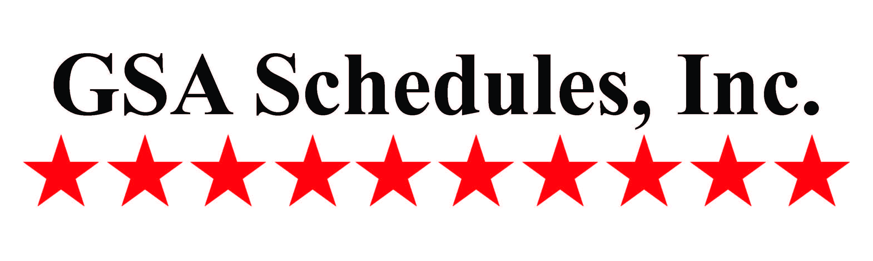

#### SERVICES

#### GSA SCHEDULES, INC.



*Celebrating over 30 years*

*of service!*

***Lynn A. de Séve, President*  
PARTNERSHIPS TO BUILD UPON**

[](http://www.siaonline.org/)

***CELEBRATING 50 YEARS***

***Secretary, SIA Board of Directors  
Chair, SIA Government Policy Group***

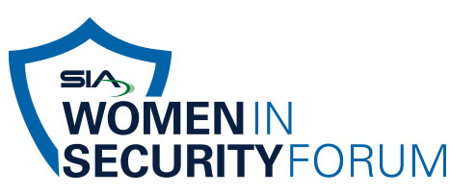

|  |  |  |  |  |  |  |  |  |  |
| --- | --- | --- | --- | --- | --- | --- | --- | --- | --- |
|  |  |  |  |  |  |  |  |  |  |

* GSA Feasibility and Market Study
* GSA Schedule Submission through Contract Award Support
* Award Start Up Requirements
* GSA Advantage Upload
* Staff Training for GSA Sales, GSA Compliance and Reporting
* GSA Contract Maintenance Modifications and Updates
* GSA Annual Contractor Assessment
* Daily Review of GSA eBuy
* GSA Sales Reporting
* Development of GSA Dealer Program and Support
* Manufacturer Consulting
* State Contract Submission and Maintenance

The GSA Experts

to the Security Industry

*GSA Schedule Support Services*



1997 Annapolis Exchange Parkway

Suite 300

Annapolis, MD 21401

Phone: (301) 805-1300

www.gsa-schedules.com



#### Follow us on Twitter Like us on Facebook Visit our [WebSite](http://www.gsa-schedules.com) @GSASchedulesInc www.Facebook.com/GSA.Schedules.Inc. [www.gsa-schedules.com](http://www.gsa-schedules.com)

# ADVANTAGES OF HAVING

# A GSA CONTRACT

* Whether buying as a Government agency or selling goods or services to the Government, General Services Administration (GSA) Multiple Award Schedule (MAS) Contract Program provides a highly efficient and streamlined process.
* Once your GSA Contract is awarded, agencies can easily access information on your products and services using the following eTools:
* GSA e-Library
* GSA Advantage!
* GSA eBuy

**GSA SCHEDULES, INC.   
Lynn A. de Séve, President  
301-805-1300 (ofc)  
301-346-5761 (cell)**

# SUPPORT YOU CAN DEPEND UPON

* We provide personalized service to help ensure the proper placement of products and services on the GSA Schedule Contract.
* We compile a comprehensive, competitive analysis and detailed sales history to determine how best to position and price your offer.
* We provide ongoing support and maintenance once your contract has been awarded.
* We have excellent, long-standing relationships with GSA directors and contracting officers.

# EXPERIENCE YOU CAN TRUST

* For over 30 years, we have played an instrumental role in the success of the GSA Program for many leading security industry companies including manufacturers, integrators and professional service providers.
* Our experienced staff is always available to assist with:
  + GSA and State Contract submission & negotiation;
  + Implementation and training;
  + Establishing back office procedures for compliance;
  + Maintaining your GSA Schedule Contract in good standing, etc.